.bind() makes a ***permanent*** context link and will always keep it

* cannot change its linked context when using .call() or .apply() with different context
* even rebound does not have any effect

Constructor invocation

* only way to change an already bound context
* not something you would normally do
* must use regular, non-bound functions

Example Code:

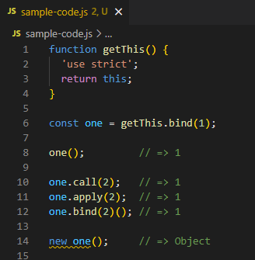

.bind()() – rebinding/rebound

Only new one() changes the context of the bound function. Other types of invocation always have this equal to 1.